95.02.02
To Albert Molineux

The sender is evidently intent on research, and his locality is deserving of careful collecting. Now, as the rains and the cessation of great heat will allow the minute plants also to reappear in their ephemeral course of life, your friends might be induced to form a complete collection of flowering or seeding specimens through the season. Each specimen should be placed separately in an envelope opening from one of the ends, whole plants or pieces, with flowers, or seeds, or both flowers and seeds. These could be dried in the sun or by the fireside. All sorts of plants in flower are wanted from Central Australia, and if sent in small packages as collected they would be of immense service in gradually settling the geographic distribution of very many species. Besides this, there would be the chance of new discoveries, for which the discoverers will always receive due credit. Aquatic plants are particularly valuable, especially the very small or minute sorts. The annexed sketch shows one very rare form of aquatic plant of South Europe and South Asia, which has been found in Australia only in Queensland in two localities.

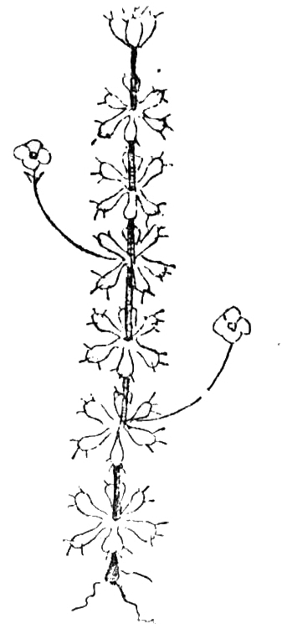

ALDROVANDA VISICULOSA. White flowers; grows submerged amongst other aquatic plants.

Aldrovanda visiculosa

Letter not found. The text given here is from 'Plant collecting', Adelaide observer, 16 March 1895, p. 4. The text is introduced by ' Baron F. von Mueller, writing from Melbourne to the General Secretary of the Agricultural Bureau on February 2, giving identifications of twenty-one plants sent down from William Creek, [SA] says:—'.
Unidentified.
The sketch reproduced here occupies one column width in the newspaper.
Typesetter's misreading of vesiculosa?

